Lithuanian Music and Theatre Academy (LMTA), Vilnius, Lithuania

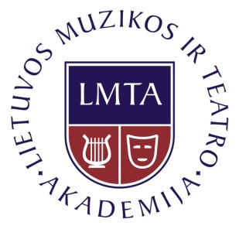



***RECONSIDERING ACTORS’ TRAINING***

*École des Écoles teacher seminar, Vilnius, 23 – 26 October 2014*

**REGISTRATION FORM**

**Completion date 6th of October!**

* Name:
* Institution, position :
* Arrival/ departure date and time:
* Registration of presentation (Presentation of approaches, methods and techniques of actors training ( holistic method examples integrating variuos disciplines in charge for developing basic acting skills; model of actors training and/or particular subject of participants interest) *- Participants are welcome to bring any materials of their work (preferably power point presentation or video/cd/dvd recordings) and to share specific exercises or elements of training they use in the teaching process. Each presentation will be given 15 minutes.*   
  Are you going to give a presentation? write **„yes“ or „no“,** if „yes“ write **a topic** or few sentences what about are you going to speak and what **equipment** will be needed :
* Registration of evening program (october 24th (Friday) and october 25th (Saturday) evening program events is optional. Please **mark the events** that you are interested in **both days** (information about events is attached to the schedule):

**October 24th (Friday)** *-17.00- 22.30 „Išvarymas“ ("Expulsion") written by Marius Ivaškevičius, directed by Oskaras Koršunovas; Lithuanian National Drama Theatre Gedimino st. 4,* [*www.teatras.lt*](http://www.teatras.lt)

Performance is sold-out already. We reserved 10 tickets for special price - 35 Litas (10 EUR) - 18*.00- Lithuanian Music and Theatre Academy recent students work; more information will be provided   
LMTA Theatre Manufactory, Kosciuškos st. 10, LT-01100 Vilnius*

**October 25th (Saturday)**  
- *19.00* *Premiere of conteporary dance performance „Grytutė ir Grytutė“ (Grytutė and Grytutė), choreografers Sigita Juraškaitė, Agnietė Lisičkinaitė \*\** Registration in advance  
 *Menų spaustuvė - Arts Printing House , Siltadarzio st. 6,* [*www.menuspaustuve.lt*](http://www.menuspaustuve.lt)  
 -*18.00 Lithuanian Music and Theatre Academy recent students work; more information will be provided   
LMTA Theatre Manufactory, Kosciuškos st. 10, LT-01100 Vilnius*

* Please inform us if you are vegetarian/vegan:
* Please return the registration form to Barte Liagaite, [barte.liagaite@gmail.com](mailto:barte.liagaite@gmail.com)